FOR IMMEDIATE RELEASE: November 5, 2025
Contact Name: Bill Armstrong
Twin City Fan Companies, Ltd.
barmstrong@tcf.com; 612.356.5149

Twin City Fan Companies, Ltd. Announces Major Expansion to Enhance Manufacturing Capabilities in Sunguvarchatiram, Tamil Nadu, India.
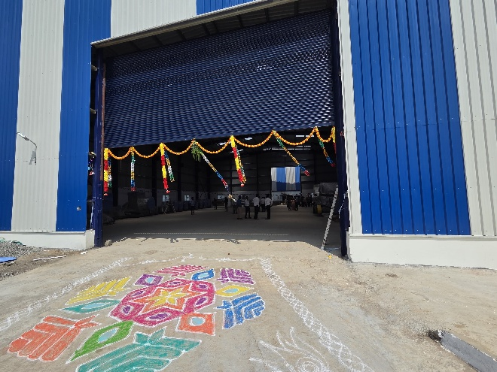
MINNEAPOLIS, MN — Twin City Fan Companies, Ltd. is proud to announce a significant expansion of its manufacturing operations in India at Twin City Fan India Private Ltd, a wholly-owned subsidiary of Twin City Fan Companies, Ltd., USA. This strategic move is aimed at strengthening production capabilities, improving efficiency and delivering even greater value to domestic and international customers.
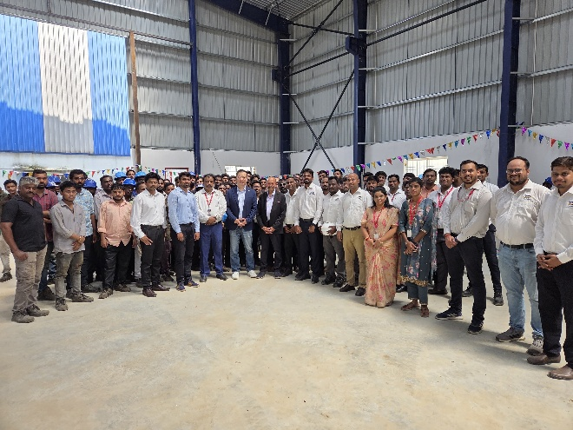
Key Highlights of the Expansion:
- Shop Floor Expansion: Increased from 30,000 sq. ft. to 50,000 sq. ft. enabling higher production outputs.
- Extended Warehouse Facility: Added 15,000 sq. ft. of secured storage, capable of housing a minimum of 30 mixed centrifugal fans for better inventory management.
- Production Capacity Boost: 50% increase through the addition of sophisticated machinery for ease of manufacturing of medium and heavy-duty centrifugal fans.
- Advanced Testing Capabilities: Now equipped with up to 150 HP full-load tests, ensuring superior product reliability.
- Workforce Growth: Expanded by 50% to support increased production and faster delivery timelines.
- Blasting & Paint Shop Added: To maintain high standards in quality and aesthetics, ensuring every product meets customer expectations.
- EOT Cranes Installed: Heavy-duty 10-ton cranes added to support the handling and assembly of large industrial fans efficiently and safely.

Commitment to Excellence
This expansion reflects TCF India’s commitment to:
- Improved Capacity: Faster turnaround times and increased production volumes.
- Advanced Technology: Incorporating state-of-the-art equipment for superior quality and efficiency.
- Sustainable Growth: Building a future-ready facility aligned with environmental standards.
“This expansion marks a major milestone for TCF India. By increasing our production capacity and adding advanced testing and finishing capabilities, we are better positioned to meet the growing demands of our customers while maintaining the highest standards of quality and reliability," said Larry Tan, Executive Vice President of International Sales.
About Twin City Fan Companies, Ltd.
Our Twin City Fan & Blower, Aerovent and Clarage sales channels offer a full spectrum of air moving equipment that helps create optimized solutions for industrial, commercial, agricultural, institutional, municipal, transportation and many other industries. Headquartered in Minneapolis, MN with approximately 1,500 employees globally, Twin City Fan Companies has been creating better indoor environments since 1874. For more information about Twin City Fan Companies, Ltd., please visit twincityfan.com.

